RESUME

# KARTHIKEYAN S

# Cell: +91 9597619013

# Email: skarthikn14@gmail.com

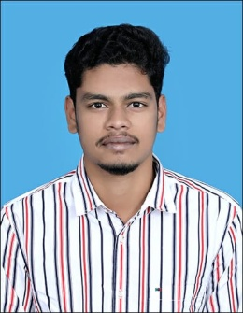

# Career Objective:

To be an energetic, enthusiastic and innovative person by utilizing all my skills and knowledge and scope up with all my superiors and subordinates for the successful growth and development of the concern.

# Educational Qualification:

* MBA with 77% of marks at Bharathiar University, Coimbatore.
* Passed with 62.3% of marks in BCA at National College, Trichy.
* Passed with 60% of marks in 12th at Cheran Matric Higher Secondary School, Karur.
* Passed with 77% of marks in 10th class at Cheran Matric Higher Secondary School, Karur.

**Technical Skills:**

* **HTML**
* **CSS**
* **JAVASCRIPT**
* **Basics of php, Mysql, bootstrap, jQuery, angular js**

# Course Work and Certification:

* Undergoing **Web Development** course at Softlogic institute at Chennai.
* Undergoing **Angular js** course at Softlogic institute at Chennai.
* Completed **DCA** and **DTP** at csc.
* Attended workshop in **IOT** at **JOSEPH COLLEGE** Trichy.

**Personal Profile:**

Name : Karthikeyan S

Father Name : Shanmugasundaram R

Date of Birth : 14-May-1999

Languages Known : English and Tamil

Address : 67, Sengunthar Nagar,

8th cross, Vengamedu,

Karur - 639006.

# Hobbies:

* Capturing photos and editing photos and videos.
* Playing Cricket and Carrom.

# Declaration:

I hereby declare that the above information is correct and true to the best of my knowledge and belief.

# (KARTHIKEYAN S)

# Place:

# Date :